**P235/4**

**ISLAMIC RELIGIOUS**

**EDUCATION**

**(Islam of Africa)**

Paper 4

Jul/Aug 2019

3 Hours

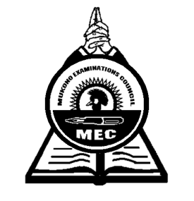

**MUKONO EXAMINATION COUNCIL**

**Uganda Advanced Certificate of Education**

**ISLAMIC RELIGIOUS EDUCATION**

**(Islam of Africa)**

Paper 4

3 Hours

**INSTRUCTIONS TO CANDIDATES**

*Attempt any* ***four (4)*** *questions one from each section.*

*All questions carry equal marks*

*Any additional question(s) answered will not be marked.*

**SECTION A**

**ISLAM IN EAST AFRICA**

1. Discuss the factors responsible for the spread of Islam in East Africa. ***(25 marks)***
2. What factors have contributed to the slow spread of Islam in Kenya. ***(25 marks)***
3. To what extent did the similarity between Islam and African aid in the Islamisation in Kenya?

***(25 marks)***

1. Explain the limitation to the spread of Islam during the 19th century in Uganda. ***(25 marks)***
2. Discuss the factors that have limited the progress of Muslim education in Africa. ***(25 marks)***
3. Discuss the social and religious life of Muslim in Tanzania. ***(25 marks)***

**SECTION B**

**ISLAM IN WEST AFRICA**

7. Write brief note on the following orders.

(i) The qadriyyah order ***(13 marks)***

(ii) The sufi order ***(12 marks)***

8. What lessons can be advanced to explain why there was Islamic stagnation and Pegan reaction in the 17th and 18th century? ***(25 marks)***

9. What role did the jihads of the 19th century in West Africa play in the spread and revival of

Islam? ***(25 marks)***

10. Using specific example in Africa, assess the view that imperialism affected the progress of Islam in West Africa. ***(25 marks)***

11. Discuss the role of Traditional leader for the spread of Islam in West Africa. ***(25 marks)***

12. What were the contribution of the suffi towards the spread of Islam.

***End -***